Final Interim Report

Mixed Reality – MR DrumKit

Final Year Project 2017

Department of Computer Science

The University of Hong Kong

Wong Ho Sum, Crystal UID: 3035180108

Supervisor
Dr. Yi-King Choi
Research Assistant Professor of Computer Science

27th Nov. 2017

Abstract

Drum kits are large and noisy instruments that are not very accessible to many people. This hinders budding drummers from starting and obstructs regular players from practising. However, with the help of mixed reality technologies, realistic virtual drumming experience can be provided. This paper describes the background, design, and project progress of MR DrumKit, a mixed reality HoloLens application that utilises Kinect to simulate drumming. The project that this paper describes is progressing slower than scheduled. Preliminary research was done and the development platform was set up, but the design is yet to be completed. For the next step, the design stage should be done concurrently with the implementation stage to catch up the progress.

Acknowledgment

I would like to thank my supervisor, Dr Y K Choi for her guidance and suggestions in this project, and Dr. K L Ho for teaching me how to write academic reports.

Abbreviations

MR | Mixed reality
VR | Virtual reality

Table of Contents
0.1 List of Tables 7
0.2 List of Figures 8
1. Introduction 9
1.1 Background 9
1.2 Related Works 9
1.2.1 Aerodrums 9
1.2.2 DrumKit VR 10
1.3 Merging MR technology with Drum Kits 10
1.4 Outline of this paper 10
2. Objective 11
2.1 Scope 11
3. Approach 12
3.1 HoloLens 12
3.1.1 Hololens Hardware 12
3.1.2 Justifications for choosing the Hololens 13
3.2 Kinect 14
3.2.1 Kinect Hardware -- Camera 14
3.2.2 Kinect Middleware 15
3.2.3 Justifications for choosing the Kinect 15
3.3 Unity 16
3.4 Development Environment 17
4. Design 18
4.1 Set up of the MR DrumKit 18
4.2 Using the MR DrumKit 19
4.2.1 Standard Air Drums mode 19
4.2.2 Custom Drum Kit mode 19
4.2.3 Application Customisation 20
4.2.4 Extra Features for Future 20
4.3 Limitations of Hardware 21
4.3.1 Kinect 21
4.3.2 Hololens 21
4.3.3 User Environment 21
5. Current status/Previous works 22
5.1 Background Research on Related Technologies 22
5.1.1 Motion Capturing Technology 22
5.2 Development Environment Setup 23
5.2.1 Initial Setup (before 22nd October 2017) 23
5.2.2 Second Setup (after 22nd October 2017) 23
5. 3 Logic/Algorithm Design 24
6. Discussion of Progress/Work to be Done 25
6.1 Catching up Design Progress 25
6.2 Experiments on Drum-Hit Detection Algorithm 25
6.3 Explore Programs for turning Kinect data into Unity-compatible data 25
6.4 Algorithms for 3D Avatar Modelling 25
6.5 Testing Hololens-Kinect connectivity 26
6.4 Revised Schedule 27
7. Conclusion 28
8. References 29
9. Appendices 31
9.1 Original Project Schedule in Project Plan 31

List of Tables

Table 1: Platforms/Tools used in this project 17
Table 2: Revised Schedule 27

0.2 List of Figures

Figure 1: Aerodrums 9
Figure 2: DrumKit VR 10
Figure 3: Microsoft HoloLens 12
Figure 4: Position of cameras and sensors on Hololens 12
Figure 5: Microsoft Kinect 14
Figure 6: Data Flow inside Kinect 15
Figure 8: Set up of MR DrumKit 18

1. Introduction

1.1 Background
Budding drummers usually face a problem: they wanted to play the drums, but drum sets are not easily available. Drum sets are relatively large instruments, and many people, especially in Hong Kong, cannot afford the space to own a drum set. While people can also go to studios, this option is expensive and inconvenient. To make the instrument more accessible, mixed reality technologies can be used to let drummers play drums regardless of location and availability of physical drum sets.

1.2 Related Works

1.2.1 Aerodrums
Similar ideas have been explored in the field. The commercial air-drumming product Aerodrums [1] utilises high-speed motion capture to let users play drums on the air (see Figure 1(1)). However, this product offers visual feedback only on a computer screen (see Figure 1(2)). It can be difficult to have an immersive experience of drumming. It is also relatively difficult to grasp the location of different drums in relative to the drumsticks, especially for beginners [2].

2

1
Figure 1: (1) Users hit the air to hit the invisible drums. (2) Users can see the position of the sticks relative to the drums on the computer screen.
Taken from [3] https://www.pcmarket.com.hk/

1.2.2 DrumKit VR
The virtual reality (“VR”) drum kit DrumKit VR [4] offers a visible virtual drumming experience to players (see Figure 2(1)). Players use HTC Vive’s tracked motion controllers as sticks to play with the kit. However, players cannot see their hands and feet (see Figure 2(2)). It is not possible to see if the gestures of the hands are correct. In addition, players cannot use their feet to control the drums like a real drum kit because feet motion is not captured in Vive. There is still some distance between this software and a real drum kit.

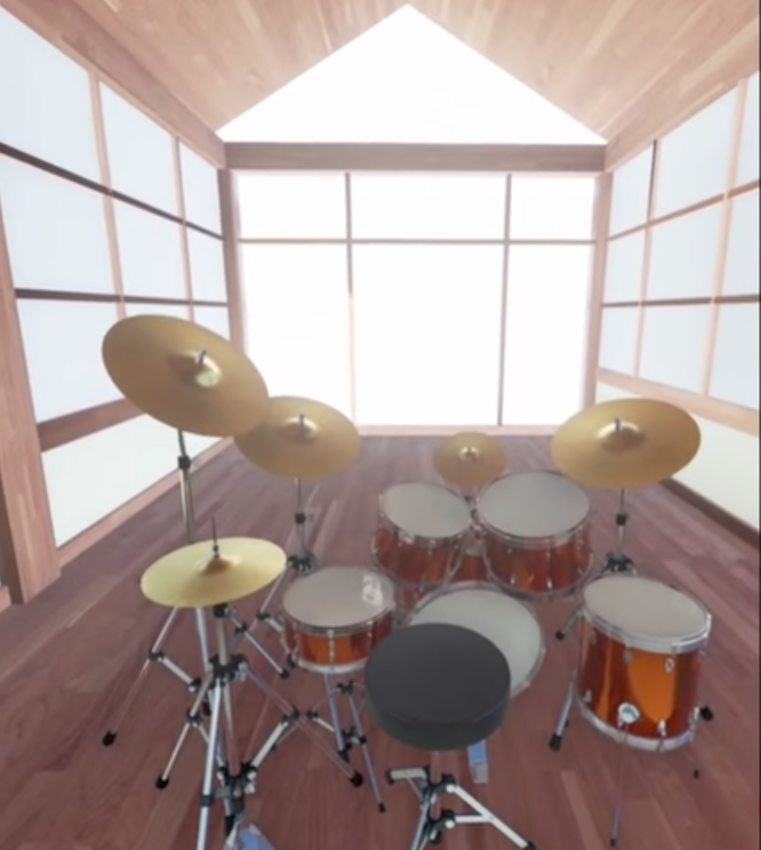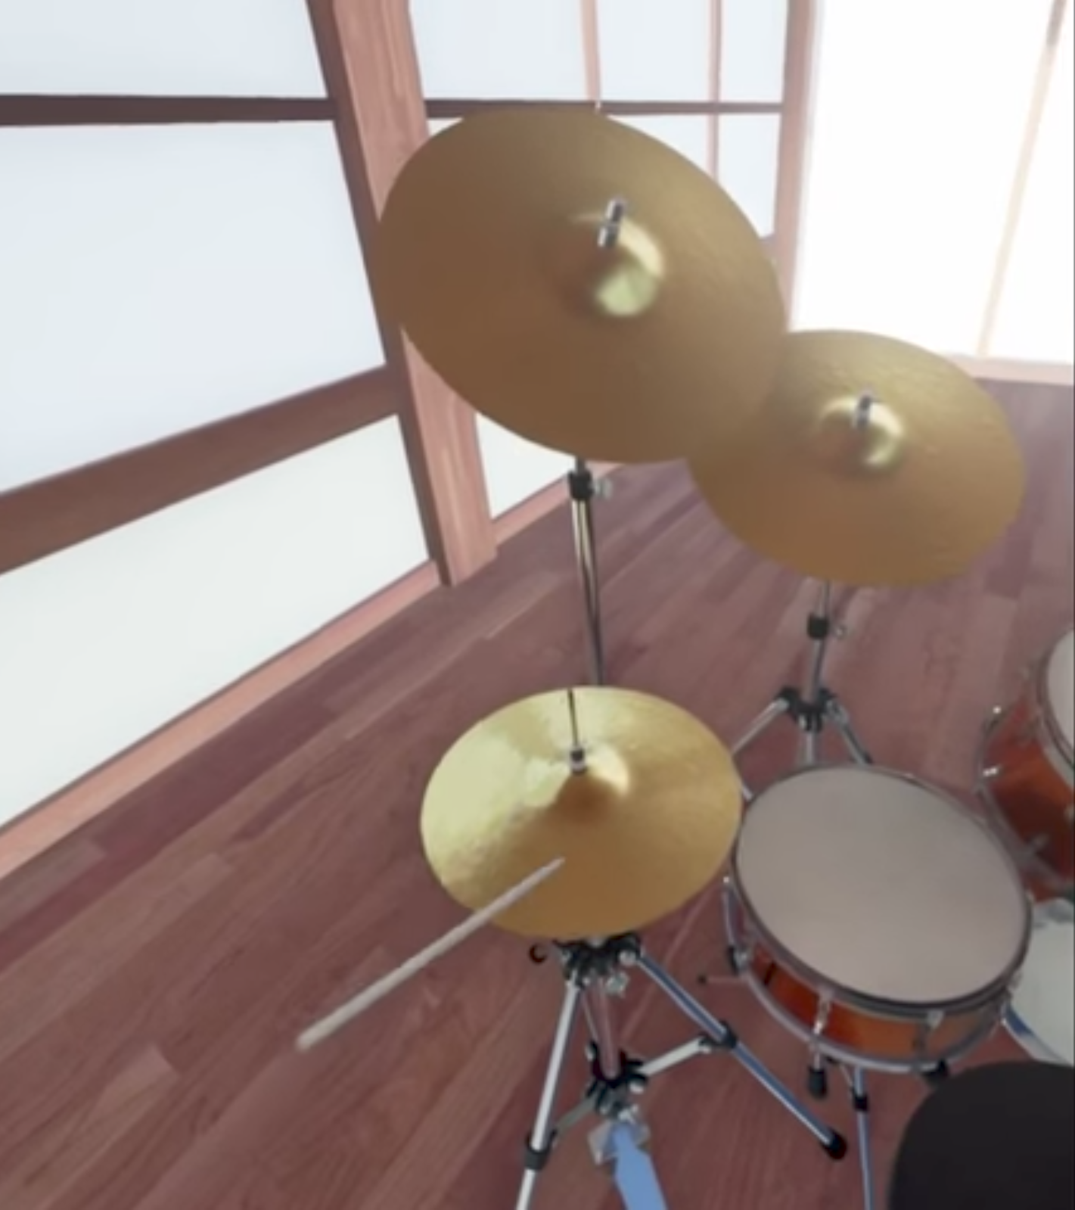

2

1
Figure 2: (1) A virtual drum set that players can see. (2) Players cannot see their hands.
Taken from [5] https://www.youtube.com/

1.3 Merging MR technology with Drum Kits
By using mixed reality (“MR”) technology, a closer simulation of a real drum kit can be achieved. Mixed reality projects virtual projections onto the user’s real environment. Users will be able to view the real and virtual worlds at the same time. Users can interact with the virtual world with hands and feet by motion-capturing peripherals. Merging drums with MR can provide users a more accessible and realistic air-drumming experience.

1.4 Outline of this paper
This paper reports the progress of this MR drums project. First, it introduces MR DrumKit, a mixed reality application for HoloLens. Then, the details of implementation are introduced. To justify the engineering choices, background information of the related software/hardware are provided. Next, the project progress is reported. The results of progress and limitations are discussed. Finally, this paper is closed with recommendations and plans for the future.

2. Objective

This project aims to develop an MR drum set application that allows users to play the drums without needing a real drum set. MR DrumKit aims to provide a feasible, accessible and realistic drumming alternative to users.

2.1 Scope
The intermediate goal of the project is to develop a prototype application. This prototype includes 2 drumming modes: the standard air drums mode and custom drum kit mode.

In the standard air drums mode, a drum set hologram is projected in front of the user. The user hit the drums with sticks to produce corresponding sounds. Users can also step on the floor to hit the pedals.

In the custom drum kit mode, users can choose different flat surfaces as drum pads. Users hit the selected surfaces to produce corresponding sounds.

The final goal is to develop a more advanced version based on the prototype. More customisation is introduced, such as allowing users to customise the position of different drums in the standard air drums mode or having more choices of drum kits. Music can also be played during the session. A short tutorial will also be included to let beginners learn the basics of drumming.

As the focus of this application is on practicability, this application does not include beautiful graphics. In addition, due to technical constraints of peripherals, this application does not provide very precise differentiation on the intensity of forces used to hit the drums.

3. Approach

3.1 HoloLens

3.1.1 Hololens Hardware
MR DrumKit is a HoloLens application. The Microsoft HoloLens (“Hololens”) (Figure 3) is a standalone mixed reality headset. Hololens allows users to see 3D holograms projected over the real environment. Sensor units comprised of depth cameras and light sensors are positioned on the two sides of the headset to sense the environment and the user’s movements (see Figure 4). Accelerometers, gyroscopes and magnetometers are used to detect the movement of the head. 3D images are rendered differently according to the location of the head to the environment, which gives the user a sense that the image is a real 3D object. The Hololens runs on Windows 10. [6] [7] [8]

Figure 3: The Microsoft HoloLens
Taken from [9] https://www.microsoft.com/
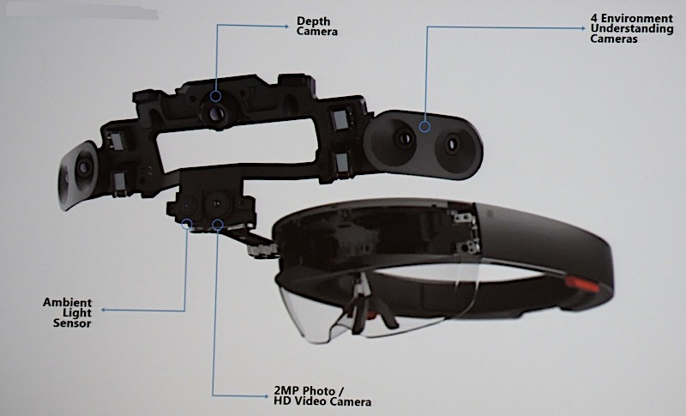
Figure 4: The position of cameras and sensors on Hololens
Taken from [10] http://image-sensors-world.blogspot.hk/

3.1.2 Justifications for choosing the Hololens
Hololens is used for this project because it is the only MR equipment that does not require any tethering to a computer. Users might have body and head movements when playing the drums. They can feel freer to move along with the rhythm.

Hololens’ scanning capability is also utilised to detect the user’s environment. The Hololens scans for the floor and flat surfaces. The Hololens scans for the floor to project the drum set on the floor in the standard air drums mode. The Hololens also scans for flat surfaces for the user to choose as different drums in the custom drum kit mode.

Hololens’ scanning capability is also used to detect user gesture input. Users can set some options using hand gestures, such as setting the volume and switching between drum sets.

3.2 Kinect
Kinect (Figure 5) is used for capturing user’s hand and feet movements. The technology Structured Light is used to compute a depth map, and machine learning is used to analyse body position [11].
Figure 5: The Microsoft Kinect
Taken from [12] https://www.xbox.com/

3.2.1 Kinect Hardware -- Camera
Unlike older software programs that uses difference in colour and texture to distinguish objects from the background, the Kinect uses the Time of flight technology [13]. The Kinect transmits near-infrared light and measures the time it needs to travel back after reflecting off objects. This technology can eliminate some false positives because it solves the problem of ambient light. The Kinect can distinguish depth of objects within 1 cm and width and height within 3mm [13].

3.2.2 Kinect Middleware
The Kinect uses an on-board processor to map raw data to render three dimensional images. The middleware uses a randomised decision forest to distinguish objects from backgrounds, human body parts, joints, faces and movement [11] [13]. The algorithm was trained from over 1 million training examples [11]. By using machine learning, the Kinect is able to model raw data into 3D avatar shapes. The combine use for hardware and software allows the Kinect to detect and track 48 different human joints on up to 6 human bodies and repeats 30 times every second [14]. Figure 6 shows the flow of data in Kinect: the data is captured by the camera, then processed into information by the middleware and finally passed into end-use software to create useful output.
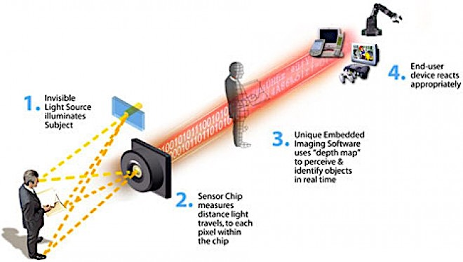
Figure 6: How data is passed from hardware to middleware and finally to end-user software inside the Kinect.
Taken from [13] https://www.wired.com/

3.2.3 Justifications for choosing the Kinect
The Kinect provides precise detection of human joints which is crucial to the implementation of this Application. More on the design is explained in Design section below.

The Kinect is a motion sensing device that is also developed by Microsoft, so it has good compatibility with the Hololens [6].

In addition, there are several open source projects that utilises the Kinect as inputting devices for Hololens uses e.g. Project-Infrared [15]/Cloud Compare [16]. They can be used in development/as reference in this project.

3.3 Unity
Unity is used to develop the Hololens application. Unity is a cross-platform game engine that is mainly used for game development. Unity supports the development of 2D and 3D graphics. C# is mainly used for scripting. Unity is the recommended engine for creating 3D apps for Hololens [15].

The application is developed in Unity in C#. Unity is suitable because 3D graphics is used in this project. Unity also has a comprehensive asset store, which offers ready-to-use 3D drum kit models [16].

3.4 Development Environment
Microsoft Hololens applications are developed in Visual Studio with Windows 10 SDK. Unity is used as the game engine. The Microsoft HoloLens and the Microsoft HoloLens Emulator is used for testing. The Emulator is mainly used because the Hololens is not handily available throughout the development process.

The following is a standard work flow in Hololens application development [17]:
- Build the 3D models and code the application logic in Unity.
- Build and compile the Unity app as a Unity C# project under a Windows Store\Hololens setting.
- Load the compiled project into Visual Studio as a Solution.
- Compile and deploy the project assembly to the Hololens or the Emulator.

The following platform/tools are used in this project:
Table 1: Platforms/Tools used in this project
Platforms/Tools | Notes
Windows 10 Education Operating System | Hyper-V is enabled.
Windows 10 SDK (10.0.16299.15)
Visual Studio 2017 | The following workloads are installed  - Universal Windows Platform development  - Game Development with Unity
HoloLens Emulator and Holographic Templates (build 10.0.14393.1358) | The Emulator requires Hyper-V support in the system. Only Windows 10 Pro, Enterprise, or Education versions support Hyper-V.
Unity 2017.1 | Windows Store .NET Scripting Backend is installed to allow building into a Visual Studio Solution.

4. Design

4.1 Set up of the MR DrumKit
Users should sit down while using the application. In front of the user, a Kinect module should be set up such that the whole body of the user can be captured (see Figure 8) i.e. the user should be at least 0.9 m and not further than 6 m from the Kinect camera.

Kinect
Figure 8: Set up of the application. Kinect should be set up such that the whole body of user can be captured.
Stickman figure taken from [18] http://www.clker.com/

4.2 Using the MR DrumKit
After opening the application, users can choose between the 2 drumming modes. The Kinect captures the position and movement of the user’s hands and feet. The processor inside Kinect models the movement and turn it into a 3D human avatar. The information is sent to the Hololens through the wireless network. Then the Hololens calculates if the user has hit a certain drum, and produces the corresponding sound through its speakers.

There are two methods of implementing the drum “hit” algorithm. One is a position-based detection and the other one is a velocity-based detection. Due to insufficient information on the hands-on device performance experience of the Hololens and Kinect, the method will be decided during the implementation stage. More details are discussed in the sections 5.1.1 Motion Capturing Technology and 6.2 Experiments on Drum-Hit Detection Algorithm.

Programs are used for turning data collected in Kinect to Unity-compatible information. Open source programs such as Project-Infrared and Cloud Compare will be examined for the adaptability for the project during the implementation stage. Details are provided in the section 6.3 Explore Programs for turning Kinect data into Unity-compatible data.

4.2.1 Standard Air Drums mode
In the standard air drums mode, a hologram of a drum kit is placed on the ground in front of the user. Users interact with the hologram like a real physical drum. The sounds and position of the drum kit can be customised.

4.2.2 Custom Drum Kit mode
In the custom drum kit mode, the Hololens uses its scanning ability to recognise flat surfaces designated by the users as drums. Users can place drums on any flat surfaces. For example, a user can choose a table surface as drum #1, and his chair armrest as drum #2. Whenever he hits the designated surfaces, the corresponding drum sound is produced.

4.2.3 Application Customisation
User experiences can be customised in Options. Option features are listed as below:
- Volume adjustment
- Switch between drum sounds/drum kits
- Switch between drum skins
- Customise position of the drums

4.2.4 Extra Features for Future
If development is smooth, extra features is added to the application to enhance user experience.

4.2.4.1 Tutorial Mode
A tutorial mode can be added. Music scores of simple beats is shown beside the drum kit. When the score is played, the way of playing the beat is shown on the drums via visual aid. Users can follow the instructions and the visual aids to learn the beat. Harder drum scores can be unlocked as user progresses.

4.2.4.2 Musical Score display
Users can import musical scores into the application. A virtual score can be displayed during a drum play session. Space can be further saved when physical space for scores are not needed. Score storage and management can also be facilitated.

4.2.4.3 Music Import Support
Users can import music into the application. Imported tracks can be played during a drum play session. Users can play drums along music they like.

4.3 Limitations of Hardware

4.3.1 Kinect
Due to the fixed location of Kinect, users can only remain in the area of vision of Kinect during playing. Users must face the camera in order to let Kinect capture users’ motions.

4.3.2 Hololens
The field of vision is limited to 100 degrees from the users’ point of view [19]. This is because of the limited size of the transparent screen and limited computational power on the Hololens. Holographic images are not displayed outside the screen area.

4.3.3 User Environment
MR DrumKit must be used in an environment where wireless network is steadily available. The Wi-Fi technology is utilised for communication between the Kinect and the Hololens.

5. Current status/Previous works

5.1 Background Research on Related Technologies
Research has been done to understand how the Hololens and Kinect work. We have also looked at demos of applications and projects with a similar objective to know the performance and limitations of Hololens and Kinect. From the demos, it is expected that the Hololens cannot perform complicated calculations, or else the system will be slowed. In addition, motion capturing of Kinect might have time lag. Therefore, design of MR DrumKit must be careful and well-engineered to ensure a smooth and real time user experience. [19] [20]

5.1.1 Motion Capturing Technology
For the motion capturing, there are 2 ways of deciding whether a drum is hit. The first one is to simply count it as a “hit” whenever the hand is detected at a specific position. The second one is to take in also the velocity of the hand as well as the position to determine if a drum is hit. The drum only produces sound when it is hit with a certain speed. Further research and experiments are expected in the implementation stage to get the balance between realistic and smooth user experience.

5.2 Development Environment Setup
For Hololens application development, Visual Studio and Unity running on Windows 10 is required.

5.2.1 Initial Setup (before 22nd October 2017)
For app development in this project, such an environment was set up using VMWare in a MacBook Pro. As Hololens applications are still not very common in the field, support for development is lacking. Compatibility issues arises between old and new versions of required software. Different versions were tried before the working combination is found.

The Hololens Emulator provided by Microsoft is used to test the application on a computer without a physical Hololens. The Emulator was set up in the said development environment. However, as the development environment is in a virtual machine, the speed and performance is very slow but workable.

5.2.2 Second Setup (after 22nd October 2017)
After further testing on the Initial Setup environment, it is decided that the slow speed and performance of the above setup is not a desirable environment. Although the environment is workable for test applications, it is prone to having worse performance issues when the application is more complex. A new development environment is set up in a Windows 10 desktop computer. All development onwards will be done in the new environment.

5. 3 Logic/Algorithm Design
According to the schedule, logic and algorithm design should be done by the end of October. However, substantial work has yet been done.

6. Discussion of Progress/Work to be Done

The progress of the project is slightly behind schedule due to delay by development environment setup. Application logic design is yet to be done. Please refer to 6.4 Revised Schedule for a revised full schedule.

6.1 Catching up Design Progress
An unexpected large amount of time was used for setting up and testing the development environment. Design work is yet to be done. However, design work can be done at the same time with implementation. During implementation, we can further understand the limitations and what we can expect of Hololens and Kinect by hands-on development experience on the two devices. The design can be modified and refined as we are familiarising with the devices as implementation is progressing. However, a preliminary non-technical design should be finished before the implementation stage starts.

6.2 Experiments on Drum-Hit Detection Algorithm
As for the drum-hit detection design mentioned above, tests have to be carried out to know the capacities of Hololens and Kinect. If the position-based detection method is easily implemented, time can be invested to develop the speed-based detection method. If that also works out smoothly, a more delicate system can be developed (e.g. system differentiate precisely between different speeds of the hand, thus produce a louder or smaller sound).

6.3 Explore Programs for turning Kinect data into Unity-compatible data
Data captured by the Kinect has to be transformed into information that Unity/the Hololens can read. Open source projects like Project-Infrared and Cloud Compare are software that can be used for mesh processing. These software will be examined for the usability in this project. If they are not directly applicable, the software will be used as references for the development of programs of similar functions for this project.

6.4 Algorithms for 3D Avatar Modelling
After movement data is converted into 3D avatars in the Kinect, modelling might be required to distinguish user movement. Data treatment also be required if input data is not desirable for the drumming detection algorithm. For example, data smoothing has to be done if the input data is not smooth enough/communication between Hololens and Kinect is not fast enough. The previous point is closely related and depends on the section below (see 6.5 Testing Hololens-Kinect connectivity).

6.5 Testing Hololens-Kinect connectivity
Data is transmitted wirelessly between the Hololens and the Kinect. When designing the implementation, it is noted that the speed of data transfer is a possible bottleneck for data flow. The implementation of the input data volume, input data structure and drum-hit detection method is subject to modifications base on the performance of data transfer. More experiments on the connectivity between the Hololens and the Kinect is expected. This part is carried out with priority because of the dependence of other parts.

6.4 Revised Schedule
Table 2: Revised Schedule
Month | Progress | Status
Sept | Get familiar with Unity | Completed.
Oct | - Collect user requirements  - Analysis and Design program  - Do background research on related technologies | Partially completed; application logic design is not completed.
Nov | - Do research on implementation details of related technologies  - Set up the Development environment | Completed.
Dec | Achieving the intermediate goal  - Development with Kinect  - Motion capturing with Kinect  - Experimenting on drum-hit detection  - Experimenting on data modelling  - Development with Hololens (w/ emulator)  - Displaying with Hololens  - Scanning with Hololens  - Experiments on connectivity between Hololens and Kinect  - Application logic design | To be completed
Jan - Feb | - Implementation of communication between devices  - Implementation of two drum modes | To be completed
Feb - Mar | Achieving the final goal  Fine tuning  - Improving user interface  - Adding customisation features  - Sounds and graphics enhancement | To be completed
Apr | Testing and optimisation | To be completed
*Please see Appendices 9.1 for the original Project Schedule in Project Plan

7. Conclusion

We have presented the progress of the development of a mixed reality drum kit application. This application allows users to play visible virtual drum sets regardless of the availability of a real physical drum kit.

This paper introduces and describes the implementation and current status of MR DrumKit. Development is slightly behind schedule with the design stage not yet completed. However, time can be made up by simultaneously executing the design and implementation steps. This also serves an advantage of being able to create a design closely coherent to the capabilities of devices of this project. No major change in project content or schedule is needed. It is expected that the application prototype can be delivered by April.

8. References

[1] | Aerodrums, “Aerodrums,” [Online]. Available: http://aerodrums.com/aerodrums-product-page/. [Accessed 22 October 2017].
[2] | K. Schiano, “Aerodrums - A Virtual Drum Kit!!!,” 17 December 2016. [Online]. Available: https://www.youtube.com/watch?v=wgptHLBI0e4. [Accessed 23 October 2017].
[3] | Mickey, “【正宗打空氣】aerodrums-虛擬空氣鼓夜晚打唔怕嘈/,” 20 01 2016. [Online]. Available: https://www.pcmarket.com.hk/. [Accessed 28 November 2017].
[4] | 0o0, “DrumKit VR - Play drum kit in the world of VR,” 0o0, 6 July 2016. [Online]. Available: http://store.steampowered.com/app/496910/DrumKit_VR__Play_drum_kit_in_the_world_of_VR/. [Accessed 22 October 2017].
[5] | S. Yu, “DrumKit VR - Play drum kit in the world of VR,” 3 6 2016. [Online]. Available: https://www.youtube.com/watch?v=q9d8kJf_c1c. [Accessed 28 November 2017].
[6] | J. Callaham, “Merging the Microsoft HoloLens and Kinect could get us one step closer to the holodeck,” Windows Central, 28 June 2016. [Online]. Available: https://www.windowscentral.com/merging-microsoft-hololens-kinect-could-create-holodeck. [Accessed 22 October 2017].
[7] | S. Colaner, “What's Inside Microsoft's HoloLens And How It Works,” tom's Hardware, 23 August 2016. [Online]. Available: http://www.tomshardware.com/news/microsoft-hololens-components-hpu-28nm,32546.html. [Accessed 22 Ocotober 2017].
[8] | A. Dachis, “What's the Difference Between HoloLens, Meta & Magic Leap?,” Next Reality, 15 October 2016. [Online]. Available: https://mixed.reality.news/news/whats-difference-between-hololens-meta-magic-leap-0171361/. [Accessed 22 October 2017].
[9] | Microsoft, “Microsoft HoloLens,” 28 11 2017. [Online]. Available: https://www.microsoft.com/en-us/hololens. [Accessed 28 November 2017].
[10] | V. Koifman, “Microsoft Hololens Cameras,” 26 5 2016. [Online]. Available: http://image-sensors-world.blogspot.hk/2016/05/microsoft-hololens-cameras.html. [Accessed 28 November 2017].
[11] | J. MacCormick, “How does the Kinect work?,” 2011. [Online]. Available: https://users.dickinson.edu/~jmac/selected-talks/kinect.pdf. [Accessed 22 October 2017].
[12] | Microsoft, “Kinect for Xbox One,” 28 11 2017. [Online]. Available: https://www.xbox.com/en-US/xbox-one/accessories/kinect. [Accessed 28 November 2017].
[13] | T. Carmody, “HOW MOTION DETECTION WORKS IN XBOX KINECT,” Wired, 3 11 2010. [Online]. Available: https://www.wired.com/2010/11/tonights-release-xbox-kinect-how-does-it-work/. [Accessed 28 November 2017].
[14] | R. W. Robert Cong, “How Does The Xbox Kinect Work,” Jameco, 28 11 2017. [Online]. Available: https://www.jameco.com/jameco/workshop/howitworks/xboxkinect.html. [Accessed 28 November 2017].
[15] | Microsoft, “Development overview,” [Online]. Available: https://developer.microsoft.com/en-us/windows/mixed-reality/development_overview. [Accessed 28 September 2017].
[16] | Unity Asset Store, “Drum kit for your band,” 30 March 2017. [Online]. Available: https://www.assetstore.unity3d.com/en/#!/content/84693. [Accessed 22 October 2017].
[17] | J. Odom, “How to Build a Basic HoloLens App in Minutes,” Next Reality, 10 12 2016. [Online]. Available: https://hololens.reality.news/how-to/hololens-dev-101-build-basic-hololens-app-minutes-0175021/. [Accessed 28 November 2017].
[18] | Clker, “SITTING STICKMAN CLIP ART,” 28 11 2017. [Online]. Available: http://www.clker.com/clipart-26132.html. [Accessed 28 November 2017].
[19] | A. Sharma, “Air-Drumming with Kinect,” 15 September 2013. [Online]. Available: https://www.youtube.com/watch?v=jMNOCa_jz-o. [Accessed 1 October 2017].
[20] | D. Herrero, “Air Drums with Kinect and Unity,” 7 April 2016. [Online]. Available: https://www.youtube.com/watch?v=oZHwNFxANfs. [Accessed 1 October 2017].

9. Appendices

9.1 Original Project Schedule in Project Plan
Sept | Get familiar with Unity
Oct 1 | Project plan  Project website
Oct | Collect user requirements  Analysis and Design program
Nov - Dec | Achieving the intermediate goal  Development with Hololens (w/ emulator)  - Displaying with Hololens  - Scanning with Hololens  Development with Kinect  - Motion capturing with Kinect
Jan - Feb | Implementation of communication between devices  Implementation of two drum modes
Jan 8-12 | First Presentation
Jan 21 | Intermediate Report
Feb - Mar | Achieving the final goal  Fine tuning  - Improving user interface  - Adding customisation features  - Sounds and graphics enhancement
Apr | Testing and optimisation
Apr 16-20 | Final Presentation
Apr 15 | Final Report
May 2 | Project Exhibition

